IRevolution : A Data-driven Exploration of Apple’s iPhone Impact in India

**1. INTRODUCTION:**

**1.1 Overview**

**Provide an introduction to the iPhone’s history and its global impact.**

**Highlight the significance of India as a key market for Apple.**

**This research aims to go beyond conjecture and anecdotal evidence in order to develop a thorough knowledge of the effects of the iPhone.**

**1.2. Purpose**

**iPhones provide internet access wherever there is a Wi-Fi or Cellular data connection.**

**This enables students to quickly search for information, access online resources, and conduct research on the go.**

**Include data on customer satisfaction, feedback, and reviews of iPhones in India.**

**Create interactive charts, graphs and maps to present data in an engaging and informative manner. Allow users to customize and filter data based on their interests.**

**2. Problem Definition and Design Thinking:**

2.1. Empathy Map

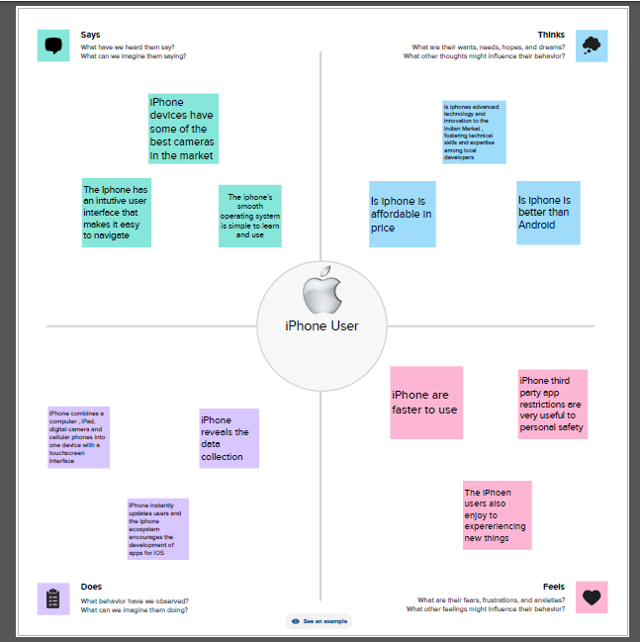

2.2. Ideation and Brainstorming Map:

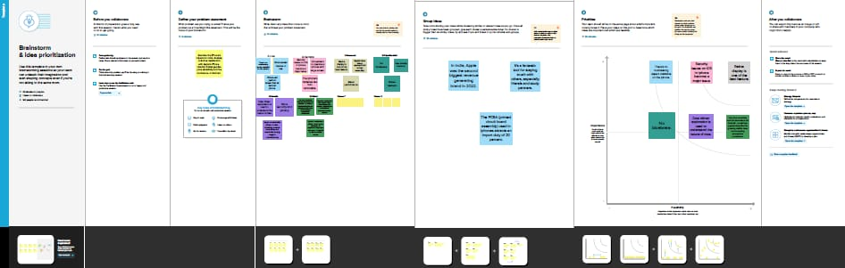

**3. RESULT:**

**Dashboard 1:**

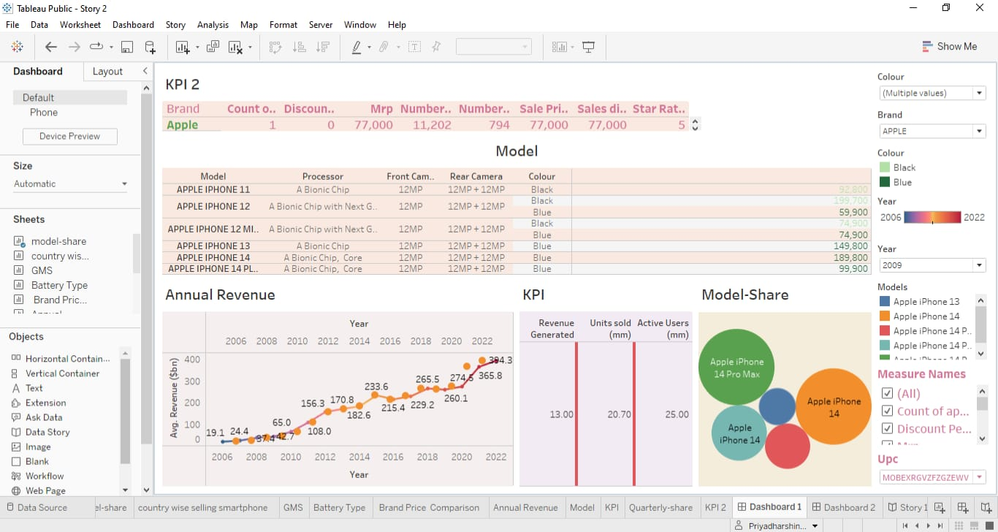

**Dashboard 2:**

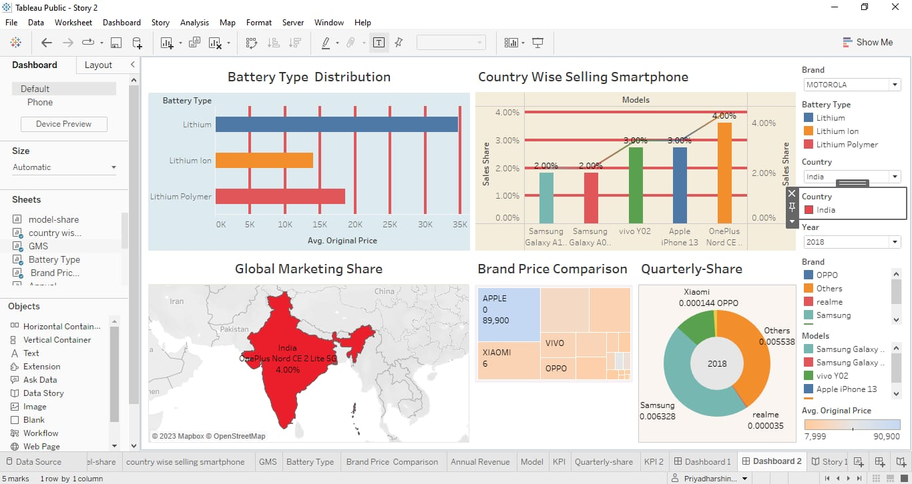

**STORY 1:**

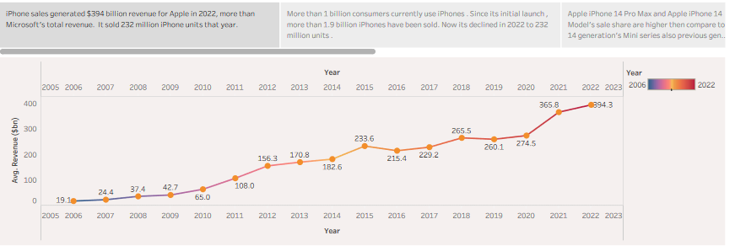

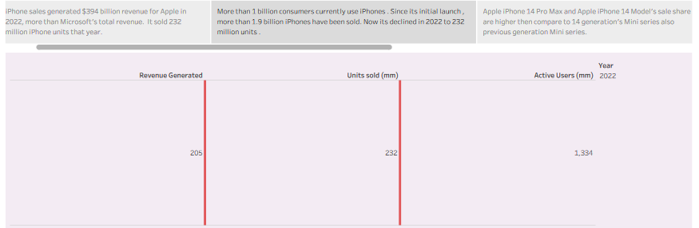

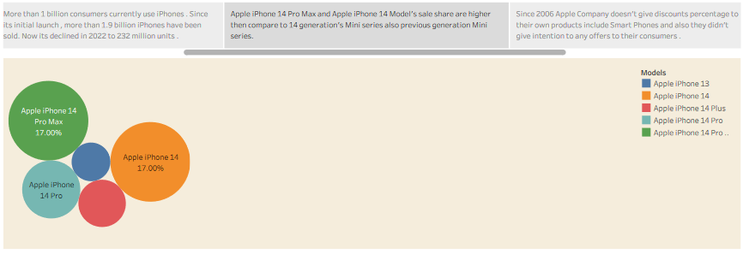

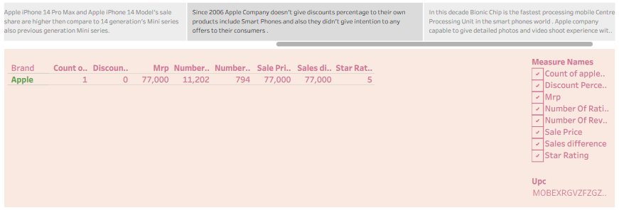

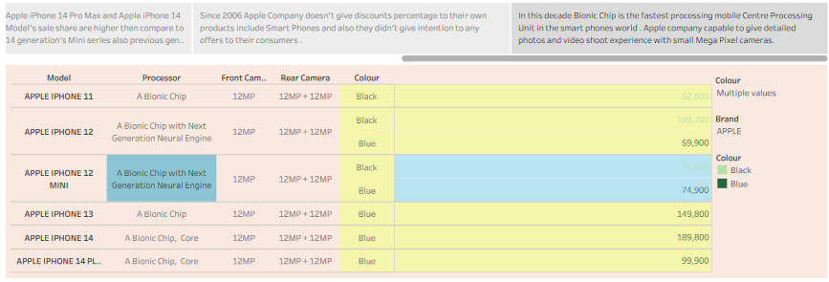

**STORY 2:**

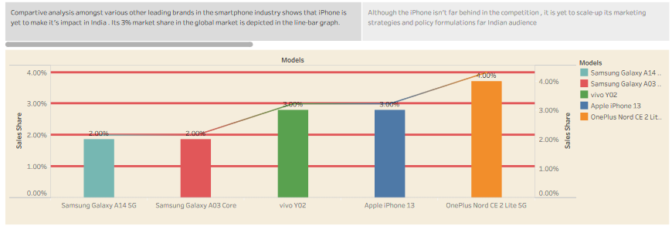

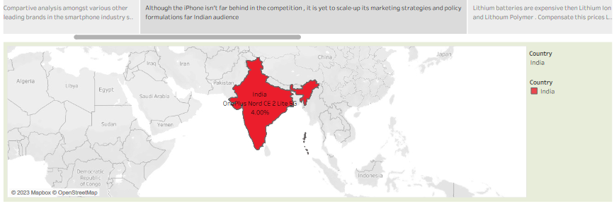

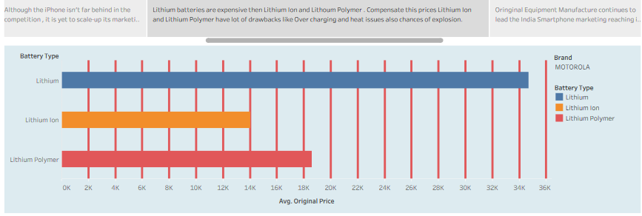

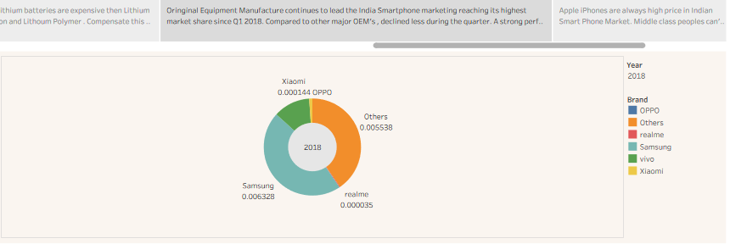

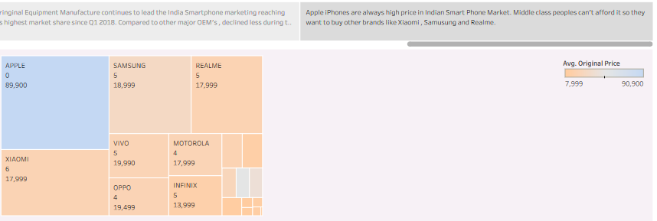

**4. ADVANTAGES & DISADVANTAGES:**

Advantages:

* **The iPhone has an intuitive user interface that makes it easy to navigate.**
* **The iPhone’s Retina display is one of the best in the market.**
* **iPhone devices have some of the best cameras in the market.**
* **The App store is unparalleled in terms of access and ease of use.**
* **The iPhone allows users to access and transfer data across multiple devices**.

Disadvantages:

* **The iPhone is one of the most expensive smart phones on the market.**
* **The iPhone’s batteries are non-removable, which means that users cannot replace them.**
* **iPhone has limited customizations options.**
* **iPhone has no expandable storage options.**
* **The iPhone is known to be fragile and prone to breaking if dropped.**

**5. APPLICATIONS:**

**It could provide a comprehensive and data-driven exploration of Apple’s iPhone impact in India, offering valuable insights to a wide range of users, from tech enthusiasts and investors to policymakers and researchers.**

**6. CONCLUSION:**

**The data-driven exploration of Apple’s impact in India underscores its transformative influence on the Indian smart phone landscape. It has not only reshaped consumer behaviour but also contributed to economic growth, technological progress, and a digital revolution. As Apple continues to adapt to the Indian market’s unique challenges and opportunities, its role in shaping India’s digital future remain a compelling narrative to watch.**

**7. FUTURE SCOPE:**

**Speculate on the future of iPhones in India, considering factors like 5G adoption, changing consumer preferences, and emerging technologies.**

**Provide insights into popular Indian apps and their performance on the App store.**